**[Name:](https://deadstartuptoys.com/product/theranos)** [Files\\Grey Literature\\Case Study\\Theranos](https://deadstartuptoys.com/product/theranos)

[¶1:](https://deadstartuptoys.com/product/theranos) **[Theranos](https://deadstartuptoys.com/product/theranos)**

[¶2:](https://deadstartuptoys.com/product/theranos)

¶3: LIFESPAN: 2 YEARSFUNDING: $724M  
¶4: Weight: 4oz  
¶5: Size: W2xD3.5xH2.8in  
¶6: Material: PVC  
¶7: Lifespan: 2 years  
¶8: Funding: $724M  
¶9: Units shipped: 0  
¶10: Retail Price: N/A

¶11: 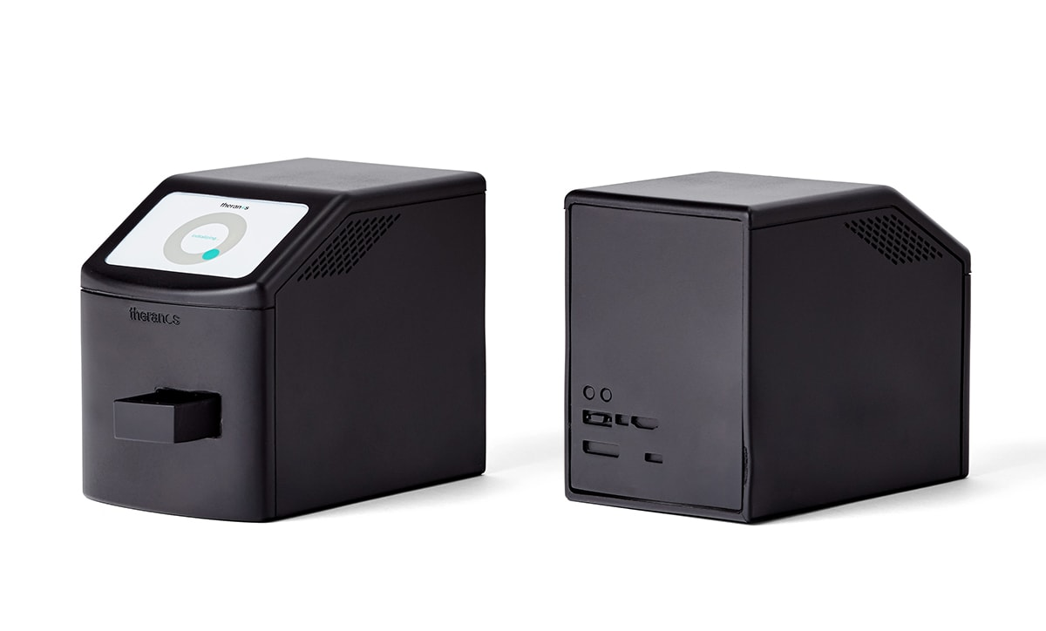

¶12: **THE STORY**

¶13: Theranos, one-time multi-billion-dollar medtech startup, created by deep-voiced Jobsian cult leader Elizabeth Holmes, managed to get as far as national rollout with a miracle device that literally did not exist. Theranos is the pinnacle of modern innovation grift and, along with WeWork, the modern Icarus, borne aloft on wings of pure VC funding.

¶14: Theranos is proof that a good idea conquers all things, including common sense and due diligence. The company sucked in money and talent while creating an oppressive, siloed atmosphere in order to perpetuate the charade of a working product for years, even among its own staff. Theranos represents the ultimate in disruptive fraud. The company falsified reports and feverishly cobbled together minimum viable results behind the facade of an utterly nonfunctional medical device in the form of a literal black box.

¶15: The specifics of Theranos defy belief. Holmes allegedly acquired a non-housebroken Husky puppy, and insisted to all comers that it was a wolf. She and company president Ramesh Balwani maintained a semi-secret relationship. And yet, investors’ blind confidence in Theranos reached extreme degrees, with some professing publicly that they would invest in another Holmes business in a heartbeat, even after Theranos was unmasked.

¶16: 

¶17: Theranos belongs alongside such storied historical grifts as the Mechanical Turk, a debacle so ludicrous it seems it ought only belong in stories. Theranos stands unrivaled in both grift and perplexity: utterly abusive towards its employees, blatantly negligent in its attitudes towards customer health, and built upon a foundation of deliberate deception.

¶18: 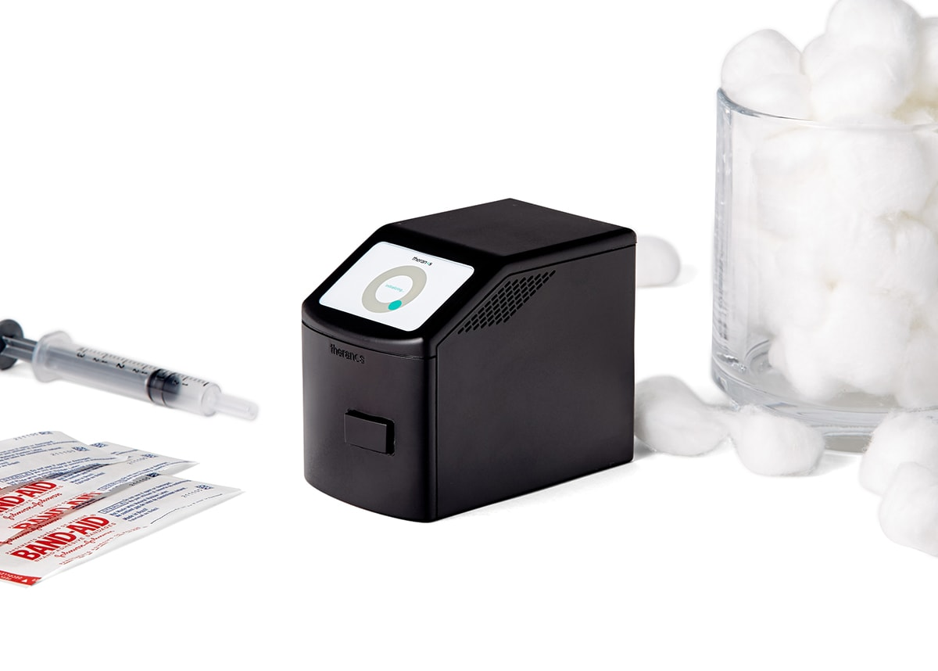

¶19:

# **¶20: Theranos**

¶21: <https://en.wikipedia.org/wiki/Theranos>

|  |
| --- |
| ¶22: **Theranos** |
| ¶23: |

|  |  |
| --- | --- |
| **¶24: Formerly** | ¶25: Real-Time Cures |
| **¶26: Type** | ¶27: [Privately held corporation](https://en.wikipedia.org/wiki/Privately_held_company) |
| **¶28: Industry** | ¶29: [Health care](https://en.wikipedia.org/wiki/Health_care) |
| **¶30: Founded** | ¶31: 2003 |
| **¶32: Founder** | ¶33: [Elizabeth Holmes](https://en.wikipedia.org/wiki/Elizabeth_Holmes) |
| **¶34: Defunct** | ¶35: September 4, 2018 |
| **¶36: Fate** | ¶37: Dissolved and [liquidated](https://en.wikipedia.org/wiki/Liquidated); founder convicted of [wire fraud](https://en.wikipedia.org/wiki/Wire_fraud) and [conspiracy](https://en.wikipedia.org/wiki/Conspiracy) |

|  |  |
| --- | --- |
| ¶38: **Headquarters** | ¶39: [Palo Alto, California](https://en.wikipedia.org/wiki/Palo_Alto,_California)  ¶40: ,  ¶41: United States |
| **¶42: Key people** | * ¶43: [Elizabeth Holmes](https://en.wikipedia.org/wiki/Elizabeth_Holmes) ([chairwoman](https://en.wikipedia.org/wiki/Chairwoman) and [CEO](https://en.wikipedia.org/wiki/Chief_executive_officer)) * ¶44: [Ramesh Balwani](https://en.wikipedia.org/wiki/Ramesh_Balwani) (president and [COO](https://en.wikipedia.org/wiki/Chief_operating_officer)) * ¶45: [George Shultz](https://en.wikipedia.org/wiki/George_Shultz) (board member) |
| **¶46: Products** | ¶47: [Blood tests](https://en.wikipedia.org/wiki/Blood_test) |
| **¶48: Services** | ¶49: [Medical tests](https://en.wikipedia.org/wiki/Medical_test) |
| **¶50: Website** | ¶51: [theranos.com](https://web.archive.org/web/20180828113917/https:/theranos.com/) at the [Wayback Machine](https://en.wikipedia.org/wiki/Wayback_Machine) (archived August 28, 2018) |

|  |
| --- |
| **¶52: Footnotes / references** ¶53: [[1]](https://en.wikipedia.org/wiki/Theranos#cite_note-Mukherjee-1) |

**¶54: Theranos** ([/ˈθɛr.ən.oʊs/](https://en.wikipedia.org/wiki/Help:IPA/English)) was an American [privately held](https://en.wikipedia.org/wiki/Privately_held_company) corporation[[2]](https://en.wikipedia.org/wiki/Theranos#cite_note-2) that was touted as a breakthrough [health technology](https://en.wikipedia.org/wiki/Health_technology) company. The company claimed that it devised [blood tests](https://en.wikipedia.org/wiki/Blood_test) that required very small amounts of blood and could be performed rapidly, thanks to the small automated devices the company had developed. However, these claims were later proven to be false.[[3]](https://en.wikipedia.org/wiki/Theranos#cite_note-3)[[4]](https://en.wikipedia.org/wiki/Theranos#cite_note-BadBlood-4)[[5]](https://en.wikipedia.org/wiki/Theranos#cite_note-5)

¶55: Founded in 2003 by 19-year-old [Elizabeth Holmes](https://en.wikipedia.org/wiki/Elizabeth_Holmes),[[6]](https://en.wikipedia.org/wiki/Theranos#cite_note-online-6) Theranos raised more than [US$](https://en.wikipedia.org/wiki/United_States_dollar)700 million from venture capitalists and private investors,[[7]](https://en.wikipedia.org/wiki/Theranos#cite_note-barrons-7) resulting in a $10 billion valuation at its peak in 2013 and 2014.[[8]](https://en.wikipedia.org/wiki/Theranos#cite_note-parloff-8)[[9]](https://en.wikipedia.org/wiki/Theranos#cite_note-9)

¶56: A turning point came in 2015, when medical research professors [John Ioannidis](https://en.wikipedia.org/wiki/John_Ioannidis) and [Eleftherios Diamandis](https://en.wikipedia.org/wiki/Eleftherios_Diamandis), along with investigative journalist [John Carreyrou](https://en.wikipedia.org/wiki/John_Carreyrou) of *[The Wall Street Journal](https://en.wikipedia.org/wiki/The_Wall_Street_Journal)*, questioned the validity of Theranos's technology. The company faced a string of legal and commercial challenges from medical authorities, investors, the [U.S. Securities and Exchange Commission](https://en.wikipedia.org/wiki/U.S._Securities_and_Exchange_Commission) (SEC), [Centers for Medicare and Medicaid Services](https://en.wikipedia.org/wiki/Centers_for_Medicare_and_Medicaid_Services) (CMS), state attorneys general, former business partners, patients, and others.[[10]](https://en.wikipedia.org/wiki/Theranos#cite_note-10) By June 2016, it was estimated that Holmes's personal net worth had dropped from $4.5 billion to virtually nothing.[[11]](https://en.wikipedia.org/wiki/Theranos#cite_note-Forbes_nothing-11) After several years of struggle, lawsuits, and sanctions from CMS, what remained of the company was dissolved on September 4, 2018.[[12]](https://en.wikipedia.org/wiki/Theranos#cite_note-TheranosShutdown-12)

¶57: On March 14, 2018, Theranos, Holmes, and former company president [Ramesh "Sunny" Balwani](https://en.wikipedia.org/wiki/Ramesh_Balwani) were charged with [fraud](https://en.wikipedia.org/wiki/Fraud) by the SEC.[[13]](https://en.wikipedia.org/wiki/Theranos#cite_note-13) On June 15, 2018, the [United States Attorney for the Northern District of California](https://en.wikipedia.org/wiki/United_States_Attorney_for_the_Northern_District_of_California) announced the indictment of Holmes on [wire fraud](https://en.wikipedia.org/wiki/Wire_fraud) and conspiracy charges. Balwani was also indicted on the same charges.[[14]](https://en.wikipedia.org/wiki/Theranos#cite_note-14) The trial was scheduled to commence in August 2020,[[15]](https://en.wikipedia.org/wiki/Theranos#cite_note-15) but it was delayed due to the [COVID-19 pandemic](https://en.wikipedia.org/wiki/COVID-19_pandemic) and Holmes's pregnancy. Holmes's trial began on August 31, 2021,[[16]](https://en.wikipedia.org/wiki/Theranos#cite_note-16) while Balwani's trial has been postponed until January 11, 2022.[[17]](https://en.wikipedia.org/wiki/Theranos#cite_note-17) Holmes was found guilty on four counts on January 3, 2022.[[18]](https://en.wikipedia.org/wiki/Theranos#cite_note-griffith-18)

## **¶58: History**

¶59: While at [Stanford University](https://en.wikipedia.org/wiki/Stanford_University), [Elizabeth Holmes](https://en.wikipedia.org/wiki/Elizabeth_Holmes) had an idea to develop a wearable patch that could adjust the dosage of drug delivery and notify doctors of variables in patients' blood.[[19]](https://en.wikipedia.org/wiki/Theranos#cite_note-19) She started developing [lab-on-a-chip](https://en.wikipedia.org/wiki/Lab-on-a-chip) technology for blood tests, with the idea to start a company that would make blood tests cheaper, more convenient and accessible to consumers.[[20]](https://en.wikipedia.org/wiki/Theranos#cite_note-never-20) Holmes dropped out of Stanford in 2003 and used the education trust from her parents to found the company that would later be called Theranos, derived from a combination of the words "therapy" and "diagnosis".[[21]](https://en.wikipedia.org/wiki/Theranos#cite_note-21)[[22]](https://en.wikipedia.org/wiki/Theranos#cite_note-22) The company's original name was "Real-Time Cures",[[8]](https://en.wikipedia.org/wiki/Theranos#cite_note-parloff-8)[[23]](https://en.wikipedia.org/wiki/Theranos#cite_note-23)[[24]](https://en.wikipedia.org/wiki/Theranos#cite_note-24) which Holmes changed after deciding that too many people were skeptical of the word "cure".[[8]](https://en.wikipedia.org/wiki/Theranos#cite_note-parloff-8)

### ¶60: Partnerships

¶61: In 2012, [Safeway](https://en.wikipedia.org/wiki/Safeway_Inc.) invested $350 million into retrofitting 800 locations with clinics that would offer in-store blood tests. However, after many missed deadlines and questionable results from a trial clinic at Safeway's corporate offices, the deal was called off in 2015.[[25]](https://en.wikipedia.org/wiki/Theranos#cite_note-25) In 2013, Theranos partnered with [Walgreens](https://en.wikipedia.org/wiki/Walgreens) to offer in-store blood tests at more than 40 locations.[[26]](https://en.wikipedia.org/wiki/Theranos#cite_note-26) Although Theranos blood tests were reportedly used on drug trial patients for [GlaxoSmithKline](https://en.wikipedia.org/wiki/GlaxoSmithKline) and [Pfizer](https://en.wikipedia.org/wiki/Pfizer), both companies stated that there were no active projects with Theranos in October 2015.[[27]](https://en.wikipedia.org/wiki/Theranos#cite_note-27)[[28]](https://en.wikipedia.org/wiki/Theranos#cite_note-Duhaime-Ross-28) In November 2016, Walgreen Co. filed suit against Theranos in a federal court in Delaware, for breach of contract. In June 2017, Theranos reported to investors that the suit, which originally sought $140 million in damages, was settled for less than $30 million.[[29]](https://en.wikipedia.org/wiki/Theranos#cite_note-29)[[30]](https://en.wikipedia.org/wiki/Theranos#cite_note-30)

¶62: In March 2015, the [Cleveland Clinic](https://en.wikipedia.org/wiki/Cleveland_Clinic) announced a partnership with Theranos in order to test its technology and decrease the cost of lab tests.[[31]](https://en.wikipedia.org/wiki/Theranos#cite_note-31)[[32]](https://en.wikipedia.org/wiki/Theranos#cite_note-:1-32) In July 2015, Theranos became the lab-work provider for Pennsylvania insurers AmeriHealth Caritas and Capital BlueCross.[[33]](https://en.wikipedia.org/wiki/Theranos#cite_note-33)[[34]](https://en.wikipedia.org/wiki/Theranos#cite_note-34)

¶63: In July 2015, the [Food and Drug Administration](https://en.wikipedia.org/wiki/Food_and_Drug_Administration) approved the use of the company's fingerstick blood testing device for the [herpes simplex virus](https://en.wikipedia.org/wiki/Herpes_simplex_virus) (HSV-1) outside a clinical laboratory setting.[[35]](https://en.wikipedia.org/wiki/Theranos#cite_note-35)[[36]](https://en.wikipedia.org/wiki/Theranos#cite_note-36) Theranos was named the 2015 Bioscience Company of the Year by the Arizona BioIndustry Association (AzBio).[[37]](https://en.wikipedia.org/wiki/Theranos#cite_note-37)

### ¶64: Exposure and downfall

¶65: In February 2015, Stanford professor [John Ioannidis](https://en.wikipedia.org/wiki/John_Ioannidis) wrote in the *[Journal of the American Medical Association](https://en.wikipedia.org/wiki/Journal_of_the_American_Medical_Association)* that no peer-reviewed research from Theranos had been published in medical research literature.[[38]](https://en.wikipedia.org/wiki/Theranos#cite_note-Ioannidis2015-38)[[39]](https://en.wikipedia.org/wiki/Theranos#cite_note-39) In May 2015, [University of Toronto](https://en.wikipedia.org/wiki/University_of_Toronto) Professor [Eleftherios Diamandis](https://en.wikipedia.org/wiki/Eleftherios_Diamandis) analyzed Theranos technology and concluded that "most of the company's claims are exaggerated."[[40]](https://en.wikipedia.org/wiki/Theranos#cite_note-Diamandis2015-40)[[41]](https://en.wikipedia.org/wiki/Theranos#cite_note-41) Attempting to boost the company's credibility, Holmes invited then U.S. Vice President [Joe Biden](https://en.wikipedia.org/wiki/Joe_Biden) to tour their facility. Biden praised what he saw,[[42]](https://en.wikipedia.org/wiki/Theranos#cite_note-42) but in order to conceal the lab's true operating conditions, Holmes and Balwani had created a fake lab for the Vice President's tour.[[43]](https://en.wikipedia.org/wiki/Theranos#cite_note-43) In October 2015, [John Carreyrou](https://en.wikipedia.org/wiki/John_Carreyrou) of *The Wall Street Journal* reported that Theranos was using traditional blood testing machines instead of the company's [Edison devices](https://en.wikipedia.org/wiki/Theranos#Technology_and_products) to run its tests, and that the company's Edison machines might provide inaccurate results.[[44]](https://en.wikipedia.org/wiki/Theranos#cite_note-44)[[45]](https://en.wikipedia.org/wiki/Theranos#cite_note-:0-45) Tyler Shultz, a Theranos employee from 2013 to 2014 and the grandson of then-Theranos director, former [U.S. Secretary of State](https://en.wikipedia.org/wiki/United_States_Secretary_of_State) [George P. Shultz](https://en.wikipedia.org/wiki/George_P._Shultz), was a key source for the WSJ story. Shultz had attempted to bring his concerns to company management, and when that had failed, he had spoken to Carreyrou and also, under an alias, reported the company to the [New York State Department of Health](https://en.wikipedia.org/wiki/New_York_State_Department_of_Health).[[46]](https://en.wikipedia.org/wiki/Theranos#cite_note-WSJ1116-46)

¶66: Theranos claimed that the allegations were "factually and scientifically erroneous."[[47]](https://en.wikipedia.org/wiki/Theranos#cite_note-47)[[48]](https://en.wikipedia.org/wiki/Theranos#cite_note-48) Walgreens suspended plans to expand blood-testing centers in their stores following the report.[[49]](https://en.wikipedia.org/wiki/Theranos#cite_note-49)[[50]](https://en.wikipedia.org/wiki/Theranos#cite_note-50) At that time, the [Cleveland Clinic](https://en.wikipedia.org/wiki/Cleveland_Clinic) announced that it would work to verify Theranos technology.[[32]](https://en.wikipedia.org/wiki/Theranos#cite_note-:1-32) Theranos fought back against the *Journal's* investigation, sending lawyers after sources in the story, including Shultz, in an effort to stop them from providing information to the press.[[4]](https://en.wikipedia.org/wiki/Theranos#cite_note-BadBlood-4)[[46]](https://en.wikipedia.org/wiki/Theranos#cite_note-WSJ1116-46) Former employees of [reputation management](https://en.wikipedia.org/wiki/Reputation_management) firm [Status Labs](https://en.wikipedia.org/wiki/Status_Labs) said that Theranos had [hired the firm to discreetly erase mentions](https://en.wikipedia.org/wiki/Conflict-of-interest_editing_on_Wikipedia) of the *WSJ*'s reporting from its [Wikipedia](https://en.wikipedia.org/wiki/Wikipedia) article, despite the activity being a violation of the website's [terms of use](https://en.wikipedia.org/wiki/Terms_of_use).[[51]](https://en.wikipedia.org/wiki/Theranos#cite_note-51)

¶67: Following the *WSJ* story, the history of FDA interactions with Theranos was scrutinized. The FDA had received a formal inquiry to look at Theranos blood test devices by the [U.S. Department of Defense](https://en.wikipedia.org/wiki/U.S._Department_of_Defense) in 2012, before the devices were commercially available and did not require FDA approval.[[52]](https://en.wikipedia.org/wiki/Theranos#cite_note-52) FDA inspection reports from 2014 and 2015 stated that its containers for blood collection were "not validated under actual or simulated use conditions" and "were not reviewed and not approved by designated individual(s) prior to issuance".[[53]](https://en.wikipedia.org/wiki/Theranos#cite_note-53) In 2015, an FDA inspection resulted in multiple observed violations of [FDA Title 21 Regulations](https://en.wikipedia.org/wiki/Title_21_of_the_Code_of_Federal_Regulations).[[54]](https://en.wikipedia.org/wiki/Theranos#cite_note-54)[[55]](https://en.wikipedia.org/wiki/Theranos#cite_note-55) It was eventually revealed that the FDA had classified Theranos's device, called a nanotainer, as a [Class II medical device](https://en.wikipedia.org/wiki/Class_II_medical_device), meaning that Theranos would need to use special labels, meet certain performance standards and perform post-market surveillance of the device. Theranos asserted that the nanotainer was a [Class I medical device](https://en.wikipedia.org/wiki/Class_I_medical_device) and therefore was not subject to any regulatory requirements.[[56]](https://en.wikipedia.org/wiki/Theranos#cite_note-56) After the 2015 inspection, Theranos announced that it would voluntarily suspend its tests apart from the FDA-approved herpes simplex virus (HSV-1) test.[[57]](https://en.wikipedia.org/wiki/Theranos#cite_note-57)[[58]](https://en.wikipedia.org/wiki/Theranos#cite_note-58)

¶68: The [Arizona Department of Health Services](https://en.wikipedia.org/wiki/Arizona_Department_of_Health_Services) reported issues with the company's Scottsdale lab meeting regulations in September 2015. The reports were revealed in the *[Arizona Republic](https://en.wikipedia.org/wiki/Arizona_Republic)* in November 2015.[[59]](https://en.wikipedia.org/wiki/Theranos#cite_note-59)

¶69: In January 2016, the [Centers for Medicare and Medicaid Services](https://en.wikipedia.org/wiki/Centers_for_Medicare_and_Medicaid_Services) (CMS) sent a letter to Theranos based on an inspection of its Newark, California lab in 2015, reporting that the facility caused "immediate jeopardy to patient health and safety" due to a test to determine the correct dose of the [blood-thinning drug](https://en.wikipedia.org/wiki/Blood_thinner) [warfarin](https://en.wikipedia.org/wiki/Warfarin).[[60]](https://en.wikipedia.org/wiki/Theranos#cite_note-60)[[61]](https://en.wikipedia.org/wiki/Theranos#cite_note-61) In 2016, Walgreens and Capital BlueCross announced a suspension of Theranos blood tests from the Newark lab.[[62]](https://en.wikipedia.org/wiki/Theranos#cite_note-62)

¶70: In March 2016, CMS regulators announced plans to enact sanctions that included suspending Holmes and Balwani from owning or operating any certified clinical laboratory for two years and that they would revoke the facility's certification as a clinical laboratory.[[63]](https://en.wikipedia.org/wiki/Theranos#cite_note-nytimes.com-63)[[64]](https://en.wikipedia.org/wiki/Theranos#cite_note-64)

¶71: By April 2016, Theranos came under criminal investigation by federal prosecutors and the [SEC](https://en.wikipedia.org/wiki/U.S._Securities_and_Exchange_Commission) for allegedly misleading investors and government officials about its technology.[[65]](https://en.wikipedia.org/wiki/Theranos#cite_note-65) The [U.S. House of Representatives Committee on Energy and Commerce](https://en.wikipedia.org/wiki/U.S._House_of_Representatives_Committee_on_Energy_and_Commerce) requested information on what Theranos was doing to correct its testing inaccuracies and adherence to federal guidelines in June 2016.[[66]](https://en.wikipedia.org/wiki/Theranos#cite_note-66)[[67]](https://en.wikipedia.org/wiki/Theranos#cite_note-67)

¶72: In May 2016, Theranos announced that it had voided two years of results from its Edison device.[[68]](https://en.wikipedia.org/wiki/Theranos#cite_note-68) The company announced that about one percent of test results had been voided or corrected from its proprietary machines in June 2016.[[69]](https://en.wikipedia.org/wiki/Theranos#cite_note-69)

¶73: In July 2016, Theranos announced that the CMS had revoked its CLIA certificate and issued sanctions prohibiting its owners and operators from owning or operating a clinical laboratory for two years, suspension of approval to receive Medicare and Medicaid payments, and a civil monetary penalty. The company discontinued testing at its Newark location while attempting to resolve the issues.[[70]](https://en.wikipedia.org/wiki/Theranos#cite_note-carreyrou-70) Theranos announced plans to appeal the decision by regulators to revoke its license to operate a lab in California and other sanctions.[[71]](https://en.wikipedia.org/wiki/Theranos#cite_note-71)

¶74: In August 2016, the company withdrew its request for emergency clearance of a [Zika virus](https://en.wikipedia.org/wiki/Zika_virus) blood test after a lack of essential safeguards during the testing process was found by federal inspectors.[[72]](https://en.wikipedia.org/wiki/Theranos#cite_note-72)[[73]](https://en.wikipedia.org/wiki/Theranos#cite_note-73)

¶75: Theranos announced that it would close its laboratory operations and wellness centers and lay off about 40 percent of its work force to work on miniature medical testing machines in October 2016.[[74]](https://en.wikipedia.org/wiki/Theranos#cite_note-auto-74)[[75]](https://en.wikipedia.org/wiki/Theranos#cite_note-open-75)[[76]](https://en.wikipedia.org/wiki/Theranos#cite_note-76)[[77]](https://en.wikipedia.org/wiki/Theranos#cite_note-77)

¶76: In January 2017, Theranos announced that it had laid off 41 percent of its workforce, or approximately 155 people, and closed the last remaining blood-testing facility after the lab failed a second major U.S. regulatory inspection.[[78]](https://en.wikipedia.org/wiki/Theranos#cite_note-78)[[79]](https://en.wikipedia.org/wiki/Theranos#cite_note-79) Also that month, the company faced lawsuits from several different entities including Walgreens[[80]](https://en.wikipedia.org/wiki/Theranos#cite_note-cnn-wal-80)[[81]](https://en.wikipedia.org/wiki/Theranos#cite_note-chicago-tribune-81) and [Arizona Attorney General](https://en.wikipedia.org/wiki/Arizona_Attorney_General) [Mark Brnovich](https://en.wikipedia.org/wiki/Mark_Brnovich).[[82]](https://en.wikipedia.org/wiki/Theranos#cite_note-82)

¶77: In April 2017, lawyers for Partner Investments LP and two other funds, with combined stakes totaling more than $96 million in Theranos preferred shares, charged that Theranos had threatened to seek [bankruptcy protection](https://en.wikipedia.org/wiki/Chapter_11_Bankruptcy) if the investors did not agree to accept additional stock equity in lieu of litigation. Theranos officials said the funds had mischaracterized the exchange offer, which was discussed before the suit was filed.[[83]](https://en.wikipedia.org/wiki/Theranos#cite_note-83) The suit also alleged that Theranos had misled company directors about its practices concerning laboratory testing and that it had secretly bought lab equipment to run fake demonstrations.[[84]](https://en.wikipedia.org/wiki/Theranos#cite_note-wsj-weaver-84) On May 1, 2017, Theranos announced that it had reached an undisclosed settlement with Partner Fund Management LP (PFM). Theranos's [General Counsel](https://en.wikipedia.org/wiki/General_Counsel), David Taylor, stated: "Theranos is pleased to have resolved both lawsuits with PFM. Although we are confident that we would have prevailed at trial, resolution of these two cases allows our tender offer to go forward and enables us to return our focus where it belongs, which is on executing our business plans and delivering value for our shareholders."[[85]](https://en.wikipedia.org/wiki/Theranos#cite_note-85) In April 2017, Theranos reached a settlement with CMS agreeing to stay out of the blood-testing business for at least two years in exchange for reduced penalties,[[86]](https://en.wikipedia.org/wiki/Theranos#cite_note-86) and signed a [consent decree](https://en.wikipedia.org/wiki/Consent_decree) with Arizona Attorney General [Mark Brnovich](https://en.wikipedia.org/wiki/Mark_Brnovich) over violations of the [Arizona Consumer Fraud Act](https://en.wikipedia.org/wiki/Arizona_Consumer_Fraud_Act). Alleged violations included [false advertisement](https://en.wikipedia.org/wiki/False_advertisement) and inaccurate blood testing. Theranos agreed to refund $4.65 million to the state's residents for Theranos blood testing services, providing a refund to every resident who had received a test, regardless of whether the test results were voided or corrected.[[87]](https://en.wikipedia.org/wiki/Theranos#cite_note-87)[[88]](https://en.wikipedia.org/wiki/Theranos#cite_note-88)[[89]](https://en.wikipedia.org/wiki/Theranos#cite_note-Mukherjee_fortune-89)[[90]](https://en.wikipedia.org/wiki/Theranos#cite_note-90)

¶78: In August 2017, Theranos announced it had reached a settlement with Walgreens.[[91]](https://en.wikipedia.org/wiki/Theranos#cite_note-91)

¶79: In December 2017, [Fortress Investment Group](https://en.wikipedia.org/wiki/Fortress_Investment_Group), a wholly owned company of [Softbank Group](https://en.wikipedia.org/wiki/Softbank_Group), loaned $100 million to Theranos for 4% of the company.[[92]](https://en.wikipedia.org/wiki/Theranos#cite_note-92) Theranos had reportedly been on the verge of bankruptcy, with the loan meant to keep the company solvent into 2018.[[93]](https://en.wikipedia.org/wiki/Theranos#cite_note-WSJ-20171224-93)[[94]](https://en.wikipedia.org/wiki/Theranos#cite_note-fortune-theranos-94)[[95]](https://en.wikipedia.org/wiki/Theranos#cite_note-cnbc-loan-95) The loan was secured by Theranos's patents.[[96]](https://en.wikipedia.org/wiki/Theranos#cite_note-96) On April 10, 2018, the company laid off the majority of workers in a renewed bid to avoid bankruptcy. The company's total headcount was down to fewer than 25 employees, after having 800 employees at its peak.[[1]](https://en.wikipedia.org/wiki/Theranos#cite_note-Mukherjee-1)[[97]](https://en.wikipedia.org/wiki/Theranos#cite_note-97) Softbank's Fortress bought up Theranos patents and later, taking advantage of the new market conditions in the midst of the [Covid-19 pandemic](https://en.wikipedia.org/wiki/Covid-19_pandemic), set up a shell company called Labrador Diagnostics which sued one of the companies making Covid-19 tests, saying that its test violated those Theranos patents.[[98]](https://en.wikipedia.org/wiki/Theranos#cite_note-98)

### ¶80: Criminal proceedings

¶81: In March 2018 the [US Securities and Exchange Commission](https://en.wikipedia.org/wiki/US_Securities_and_Exchange_Commission) charged Theranos, its CEO [Elizabeth Holmes](https://en.wikipedia.org/wiki/Elizabeth_Holmes) and former president [Ramesh "Sunny" Balwani](https://en.wikipedia.org/wiki/Ramesh_%22Sunny%22_Balwani), claiming they had engaged in an "elaborate, years-long fraud" wherein they "deceived investors into believing that its key product – a portable blood analyzer – could conduct comprehensive blood tests from finger drops of blood".[[99]](https://en.wikipedia.org/wiki/Theranos#cite_note-99)[[100]](https://en.wikipedia.org/wiki/Theranos#cite_note-100) Holmes reached a settlement with the SEC which required her to pay $500,000, forfeit 19 million shares of company stock, and be barred from having a leadership position in any public company for ten years.[[101]](https://en.wikipedia.org/wiki/Theranos#cite_note-101) Balwani did not settle with the SEC.[[102]](https://en.wikipedia.org/wiki/Theranos#cite_note-102)

¶82: On June 15, 2018, Holmes and Balwani were [indicted](https://en.wikipedia.org/wiki/Indictment) on multiple counts of [wire fraud](https://en.wikipedia.org/wiki/Mail_and_wire_fraud) and conspiracy to commit wire fraud. According to the indictment, investors, doctors and patients were defrauded. It is alleged the defendants were aware of the unreliability and inaccuracy of their products, but concealed that information. If convicted, they each face a maximum fine of $250,000 and 20 years in prison. The case, *[United States v. Elizabeth A. Holmes, et al.](https://en.wikipedia.org/wiki/United_States_v._Elizabeth_A._Holmes,_et_al.)*, has been assigned to [Lucy H. Koh](https://en.wikipedia.org/wiki/Lucy_H._Koh), [United States District Judge](https://en.wikipedia.org/wiki/United_States_federal_judge) of the [United States District Court for the Northern District of California](https://en.wikipedia.org/wiki/United_States_District_Court_for_the_Northern_District_of_California).[[103]](https://en.wikipedia.org/wiki/Theranos#cite_note-Justice61618-103)[[104]](https://en.wikipedia.org/wiki/Theranos#cite_note-104) The jury selection for the trial was to begin on July 28, 2020, and the trial was to have commenced in August 2020; however, the [COVID-19 pandemic](https://en.wikipedia.org/wiki/COVID-19_pandemic) led to a proposed October date,[[105]](https://en.wikipedia.org/wiki/Theranos#cite_note-105) before the trial for Holmes was rescheduled to begin on August 31, 2021, with Balwani's trial pushed back further to 2022.

¶83: In February 2021, federal prosecutors accused Holmes and other executives of destroying evidence in Theranos's final days in business. The specific evidence in question is the history of internal testing, including accuracy and failure rates of Theranos's blood-testing systems.[[106]](https://en.wikipedia.org/wiki/Theranos#cite_note-106)

¶84: On January 3, 2022, Holmes was found guilty of three counts of wire fraud and one count of conspiracy to commit wire fraud.[[18]](https://en.wikipedia.org/wiki/Theranos#cite_note-griffith-18)

### ¶85: Shutdown

¶86: On September 4, 2018, Theranos announced in an email to investors that it would cease operations and release its assets and remaining cash to creditors after all efforts to find a buyer came to nothing. Most of the company's remaining employees had been laid off on the previous Friday, August 31. However, Theranos general counsel and new CEO David Taylor and a few support staffers remained on payroll for a few more days.[[12]](https://en.wikipedia.org/wiki/Theranos#cite_note-TheranosShutdown-12) *The Wall Street Journal* reported that any equity investments in the company were made worthless by the shutdown.

## **¶87: Technology and products**

¶88: Theranos claimed to have developed devices to automate and miniaturize blood tests using microscopic blood volumes. Theranos dubbed its blood collection vessel the "nanotainer" and its analysis machine the "Edison".[[107]](https://en.wikipedia.org/wiki/Theranos#cite_note-rago-107)[[108]](https://en.wikipedia.org/wiki/Theranos#cite_note-108)[[109]](https://en.wikipedia.org/wiki/Theranos#cite_note-109) Holmes reportedly named the device "Edison" after inventor [Thomas Edison](https://en.wikipedia.org/wiki/Thomas_Edison), stating, "We tried everything else and it failed, so let's call it the Edison." This was likely because of a well-known Edison quote: "I've not failed. I've just found 10,000 ways that won't work."[[110]](https://en.wikipedia.org/wiki/Theranos#cite_note-110)

¶89: The blood sample was to be collected via a finger prick and then transferred to the nanotainer through Theranos's sample collection device. At just 12.9 millimetres (0.51 in) in height, the nanotainer held a couple of drops of blood.[[111]](https://en.wikipedia.org/wiki/Theranos#cite_note-111)

¶90: One of the patents for the Edison described a point of care system that could communicate with the Internet to receive instructions for which blood tests to run on the samples, before communicating these results back through the Internet. The results would then be compared to medical data available on the Internet, with the Edison running supplementary blood tests that were more targeted based on the results of the comparison. The patent was unclear on how much blood the Edison would actually require to conduct these blood tests. In one section, the patent claimed the sample needed to consist of about 10 drops of blood, but in another section, the patent claimed the Edison would need less than one drop of blood.[[112]](https://en.wikipedia.org/wiki/Theranos#cite_note-112) The technology was criticized for not being [peer reviewed](https://en.wikipedia.org/wiki/Peer_review).[[113]](https://en.wikipedia.org/wiki/Theranos#cite_note-113)[[114]](https://en.wikipedia.org/wiki/Theranos#cite_note-Issie-114) Theranos claimed to have data verifying the accuracy and reliability of its tests that would be published.[[115]](https://en.wikipedia.org/wiki/Theranos#cite_note-115) In February 2016, Theranos announced that it would permit the Cleveland Clinic to complete a validation study of its technology.[[116]](https://en.wikipedia.org/wiki/Theranos#cite_note-116) In March 2016, a study authored by 13 scientists appeared in the *[Journal of Clinical Investigation](https://en.wikipedia.org/wiki/Journal_of_Clinical_Investigation)*, where it was stated that the company's blood test results were flagged "outside their normal range 1.6x more often than other testing services", that 68 percent of lab measurements evaluated "showed significant interservice variability", and that "lipid panel test results between Theranos and other clinical services" were "nonequivalent".[[117]](https://en.wikipedia.org/wiki/Theranos#cite_note-117)

¶91: In August 2016, the company introduced a new robotic capillary blood testing unit named "miniLab" at the 2016 annual meeting of the [American Association for Clinical Chemistry](https://en.wikipedia.org/wiki/American_Association_for_Clinical_Chemistry), but did not present any data supporting the claimed abilities of the device.[[118]](https://en.wikipedia.org/wiki/Theranos#cite_note-118)[[119]](https://en.wikipedia.org/wiki/Theranos#cite_note-119)[[120]](https://en.wikipedia.org/wiki/Theranos#cite_note-120) The miniLab was allegedly capable of carrying out a range of tests from a small amount of blood. After failing to address concerns that Theranos exaggerated the capabilities of the miniLab, Walgreens withdrew from their partnership. It was later revealed that Theranos had voided two years of test results showing inaccuracies with the Edison technology.[[121]](https://en.wikipedia.org/wiki/Theranos#cite_note-121)

## **¶92: Corporate affairs**

### ¶93: Location

¶94: Theranos was headquartered in Palo Alto, California. It previously had laboratories in [Newark, California](https://en.wikipedia.org/wiki/Newark,_California) and [Scottsdale, Arizona](https://en.wikipedia.org/wiki/Scottsdale,_Arizona).[[122]](https://en.wikipedia.org/wiki/Theranos#cite_note-122)

### ¶95: Management

¶96: [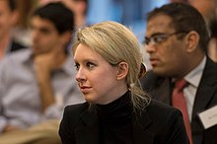](https://en.wikipedia.org/wiki/File:Elizabeth_Holmes_at_a_Nuclear_nonproliferation_discussion_in_2013_-_130417-D-NI589-107_(cropped).jpg)

¶97: [Elizabeth Holmes](https://en.wikipedia.org/wiki/Elizabeth_Holmes), the chief executive officer and founder of Theranos in 2013

¶98: From its incorporation in 2003 until 2018, Holmes was the company's chief executive officer. She recruited [Channing Robertson](https://en.wikipedia.org/wiki/Channing_Robertson), a chemical-engineering professor at Stanford, to be a technical advisor and the company's first board member during its early years. Holmes's then-boyfriend [Ramesh Balwani](https://en.wikipedia.org/wiki/Ramesh_Balwani), a software engineer whom Holmes had met during high school, joined the company as its president and chief operating officer in 2009.[[123]](https://en.wikipedia.org/wiki/Theranos#cite_note-auletta-123) In July 2011, Holmes was introduced to former U.S. Secretary of State [George Shultz](https://en.wikipedia.org/wiki/George_Shultz), who joined the Theranos board of directors that month.[[124]](https://en.wikipedia.org/wiki/Theranos#cite_note-fortune-124) Over the next three years, Shultz helped to introduce almost all the outside directors on the "all-star board", which included [William Perry](https://en.wikipedia.org/wiki/William_J._Perry) (former [U.S. Secretary of Defense](https://en.wikipedia.org/wiki/United_States_Secretary_of_Defense)), [Henry Kissinger](https://en.wikipedia.org/wiki/Henry_Kissinger) (former U.S. Secretary of State), [Sam Nunn](https://en.wikipedia.org/wiki/Sam_Nunn) (former U.S. Senator), [Bill Frist](https://en.wikipedia.org/wiki/Bill_Frist) (former U.S. Senator, senate majority leader and heart-transplant surgeon), [Gary Roughead](https://en.wikipedia.org/wiki/Gary_Roughead) (Admiral, [USN](https://en.wikipedia.org/wiki/United_States_Navy), retired), [Jim Mattis](https://en.wikipedia.org/wiki/Jim_Mattis) (General, [USMC](https://en.wikipedia.org/wiki/United_States_Marine_Corps)), [Richard Kovacevich](https://en.wikipedia.org/wiki/Richard_Kovacevich) (former Wells Fargo Chairman and CEO) and [Riley P. Bechtel](https://en.wikipedia.org/wiki/Riley_P._Bechtel) (chairman of the board and former CEO at [Bechtel Group](https://en.wikipedia.org/wiki/Bechtel_Group)).[[124]](https://en.wikipedia.org/wiki/Theranos#cite_note-fortune-124)[[125]](https://en.wikipedia.org/wiki/Theranos#cite_note-125)[[126]](https://en.wikipedia.org/wiki/Theranos#cite_note-126) The board was criticized for consisting "mainly of directors with diplomatic or military backgrounds".[[20]](https://en.wikipedia.org/wiki/Theranos#cite_note-never-20)

¶99: In April 2016, Theranos announced its medical advisory board which included past presidents or board members of the [American Association for Clinical Chemistry](https://en.wikipedia.org/wiki/American_Association_for_Clinical_Chemistry).[[127]](https://en.wikipedia.org/wiki/Theranos#cite_note-fortuneparloff-127) Members were invited to review the company's proprietary technologies and advise on the integration into clinical practice.[[127]](https://en.wikipedia.org/wiki/Theranos#cite_note-fortuneparloff-127) The board included members with relevant biomedical expertise such as past president of the [American Association for Clinical Chemistry](https://en.wikipedia.org/wiki/American_Association_for_Clinical_Chemistry) Susan A. Evans; [William Foege](https://en.wikipedia.org/wiki/William_Foege), former director of the U.S. [Centers for Disease Control and Prevention](https://en.wikipedia.org/wiki/Centers_for_Disease_Control_and_Prevention) (CDC); David Helfet, director of the Orthopedic Trauma Service at the Hospital for Special Surgery; and professors Ann M. Gronowski, Larry J. Kricka, Jack Ladenson, Andy O. Miller and Steven Spitalnik.[[128]](https://en.wikipedia.org/wiki/Theranos#cite_note-128)[[129]](https://en.wikipedia.org/wiki/Theranos#cite_note-129)

¶100: Balwani left his position as president and COO in May 2016. At that time, the company announced its new board members, Fabrizio Bonanni (former executive vice president of [Amgen](https://en.wikipedia.org/wiki/Amgen)), Richard Kovacevich and William Foege, who would help to publicly introduce its technologies.[[130]](https://en.wikipedia.org/wiki/Theranos#cite_note-130)[[131]](https://en.wikipedia.org/wiki/Theranos#cite_note-131)[[132]](https://en.wikipedia.org/wiki/Theranos#cite_note-132)

¶101: In May 2016 members of the Theranos board of directors were:[[133]](https://en.wikipedia.org/wiki/Theranos#cite_note-133)

* ¶102: [Elizabeth Holmes](https://en.wikipedia.org/wiki/Elizabeth_Holmes), founder and CEO
* ¶103: Riley Bechtel, former [Bechtel Group](https://en.wikipedia.org/wiki/Bechtel_Group) CEO
* ¶104: [David Boies](https://en.wikipedia.org/wiki/David_Boies), a founder and the chairman of Boies Schiller Flexner
* ¶105: [William Foege](https://en.wikipedia.org/wiki/William_Foege), former director of the CDC
* ¶106: Richard Kovacevich, former CEO and chairman of [Wells Fargo](https://en.wikipedia.org/wiki/Wells_Fargo)
* ¶107: [Jim Mattis](https://en.wikipedia.org/wiki/Jim_Mattis), later [U.S. Secretary of Defense](https://en.wikipedia.org/wiki/United_States_Secretary_of_Defense)
* ¶108: Fabrizio Bonanni, former executive vice president of Amgen

¶109: In December 2016, it was announced the Theranos management team would be restructured with the departure of Riley Bechtel. In January 2017, incoming U.S. Secretary of Defense nominee James Mattis resigned from the Theranos board. In January 2017 the Theranos board of directors included:[[134]](https://en.wikipedia.org/wiki/Theranos#cite_note-134)

* ¶110: Elizabeth Holmes
* ¶111: William Foege

### ¶112: Fabrizio BonanniValuation

¶113: Theranos raised **millions of dollars in its first years**. In 2004, Theranos was based in a rented basement near the Stanford campus.[[136]](https://en.wikipedia.org/wiki/Theranos#cite_note-136) By **December 2004, the company had raised more than $6 million from investors at a valuation of $30 million**.[[137]](https://en.wikipedia.org/wiki/Theranos#cite_note-WSJDec-137) **The company had about $45 million total fundraising after [Series B and Series C](https://en.wikipedia.org/wiki/Series_B) funding in 2006.**[[138]](https://en.wikipedia.org/wiki/Theranos#cite_note-138) **Theranos raised an additional $45 million in 2010 at a valuation of $1 billion**.[[137]](https://en.wikipedia.org/wiki/Theranos#cite_note-WSJDec-137)[[139]](https://en.wikipedia.org/wiki/Theranos#cite_note-139) The company moved to the former headquarters of [Facebook](https://en.wikipedia.org/wiki/Facebook) in June 2012.[[140]](https://en.wikipedia.org/wiki/Theranos#cite_note-140)[[141]](https://en.wikipedia.org/wiki/Theranos#cite_note-141) The company had significant news coverage starting in September 2013 after profiles in the *[San Francisco Business Times](https://en.wikipedia.org/wiki/San_Francisco_Business_Times)* and *[The Wall Street Journal](https://en.wikipedia.org/wiki/The_Wall_Street_Journal)*.[[20]](https://en.wikipedia.org/wiki/Theranos#cite_note-never-20) By 2014, **Theranos had raised more than $400 million with an estimated value of $9 billion.[[142]](https://en.wikipedia.org/wiki/Theranos#cite_note-142) In 2016,** ***[Forbes](https://en.wikipedia.org/wiki/Forbes)* revised the estimated net worth of the company to $800 million taking into account the $724 million of capital raised.**[[11]](https://en.wikipedia.org/wiki/Theranos#cite_note-Forbes_nothing-11)

¶114: In May 2017, participating shareholders provided a release of any potential claims against Theranos in exchange for shares of the company's new [preferred stock](https://en.wikipedia.org/wiki/Preferred_stock). Holders of more than 99 percent of the shares elected to participate. Holmes contributed shares to the company and gave up [equity](https://en.wikipedia.org/wiki/Equity_(finance)) to offset potential dilution to non-participating shareholders.[[143]](https://en.wikipedia.org/wiki/Theranos#cite_note-143)

* ¶115: **In May 2018 [John Carreyrou](https://en.wikipedia.org/wiki/John_Carreyrou) reported that American business and government leaders lost more than $600 million by privately investing in Theranos.[[144]](https://en.wikipedia.org/wiki/Theranos#cite_note-carreyrou3-144) Major investments had been made by the [Walton family](https://en.wikipedia.org/wiki/Walton_family) ($150 million)**, **[Rupert Murdoch](https://en.wikipedia.org/wiki/Rupert_Murdoch) ($121 million), [Betsy DeVos](https://en.wikipedia.org/wiki/Betsy_DeVos) ($100 million), and the Cox family (of [Cox Media Group](https://en.wikipedia.org/wiki/Cox_Media_Group)) ($100 million).[[70]](https://en.wikipedia.org/wiki/Theranos#cite_note-carreyrou-70) The final liquidation of the company in September 2018 rendered these investments worthless.[[12]](https://en.wikipedia.org/wiki/Theranos#cite_note-TheranosShutdown-12)**
* ¶116: Daniel Warmenhoven, former [NetApp](https://en.wikipedia.org/wiki/NetApp) CEO, replacing Riley Bechtel

¶117: It was also announced in November 2016 that the celebrity-studded "board of counselors" would be scrapped in January 2017.[[135]](https://en.wikipedia.org/wiki/Theranos#cite_note-135)

¶118:

## **¶119: Books and documentaries[[edit](https://en.wikipedia.org/w/index.php?title=Theranos&action=edit&section=11)]**

¶120: John Carreyrou, a *[Wall Street Journal](https://en.wikipedia.org/wiki/The_Wall_Street_Journal)* journalist whose work exposed Theranos, published a book-length treatment in May 2018 titled *[Bad Blood: Secrets and Lies in a Silicon Valley Startup](https://en.wikipedia.org/wiki/Bad_Blood:_Secrets_and_Lies_in_a_Silicon_Valley_Startup)*.[[145]](https://en.wikipedia.org/wiki/Theranos#cite_note-145) A film version was reportedly scheduled for release in 2020, starring [Jennifer Lawrence](https://en.wikipedia.org/wiki/Jennifer_Lawrence) as Elizabeth Holmes, written by [Vanessa Taylor](https://en.wikipedia.org/wiki/Vanessa_Taylor) and directed by [Adam McKay](https://en.wikipedia.org/wiki/Adam_McKay).[[146]](https://en.wikipedia.org/wiki/Theranos#cite_note-146)[[147]](https://en.wikipedia.org/wiki/Theranos#cite_note-147)[*[needs update](https://en.wikipedia.org/wiki/Wikipedia:Manual_of_Style/Dates_and_numbers#Chronological_items)*]

¶121: In January 2019, [ABC News](https://en.wikipedia.org/wiki/ABC_News)' *[Nightline](https://en.wikipedia.org/wiki/Nightline)* released a podcast and documentary about the Holmes/Theranos story called *The Dropout*.[[148]](https://en.wikipedia.org/wiki/Theranos#cite_note-148)

¶122: Also in January 2019, a [documentary film](https://en.wikipedia.org/wiki/Documentary_film) entitled *[The Inventor: Out for Blood in Silicon Valley](https://en.wikipedia.org/wiki/The_Inventor:_Out_for_Blood_in_Silicon_Valley)* about Holmes and Theranos was released. Directed by [Alex Gibney](https://en.wikipedia.org/wiki/Alex_Gibney), it made its debut at the [Sundance Film Festival](https://en.wikipedia.org/wiki/Sundance_Film_Festival) and was released to the general public in March 2019 on [HBO](https://en.wikipedia.org/wiki/HBO) platforms.[[149]](https://en.wikipedia.org/wiki/Theranos#cite_note-149)[[150]](https://en.wikipedia.org/wiki/Theranos#cite_note-150)

¶123:

**¶124: Startup Failure Post-Mortems 2018 Third Update (11/14/2018)**

### ¶125: **Theranos**

¶126: Title: [Theranos is shutting down](https://www.nytimes.com/2018/09/05/health/theranos-shutting-down.html?login=smartlock&auth=login-smartlock)  
¶127: Title Link: <https://www.nytimes.com/2018/09/05/health/theranos-shutting-down.html?login=smartlock&auth=login-smartlock>

¶128: Product: [Theranos](https://www.cbinsights.com/company/theranos)  
¶129: Product Link: <https://www.cbinsights.com/company/theranos>

¶130: The New York Times wrote about the blood testing company and its plans to shutter operations:

¶131: ‘We are now out of time,’ David Taylor, the company’s chief executive and general counsel, informed investors in an email first reported on Tuesday by The Wall Street Journal, whose in-depth investigation unraveled the company’s claims. Mr. Taylor declined to comment further, saying the letter spoke for itself.

# ¶132: Theranos

¶133: HEALTHCARE | Medical Devices & Equipment / Patient Monitoring  
¶134: [theranos.com](https://theranos.com/)

## **¶135:** Founded Year

¶136: 2004

## **¶137:** Stage

¶138: Dead | Dead

## **¶139:** Total Raised

¶140: $500M

## **¶141:** About Theranos

¶142: Theranos is a biomedical device company working on the field of Theranostics, the integration of technology with medical therapies to deliver the RIGHT drug, in the RIGHT dose, to the RIGHT patient at the RIGHT time. Theranos aims to provide clinical decision-support systems that enable pharmaceutical companies to develop safer, more efficacious drugs for individualized patient treatment.

## **¶143:** Theranos Headquarter Location

¶144: 1701 Page Mill Road

¶145: Palo Alto, California, 94304,

¶146: United States

¶147: 650-838-9292

# ¶148: **Theranos Is Shutting Down**

¶149: Title Link: <https://www.nytimes.com/2018/09/05/health/theranos-shutting-down.html?login=smartlock&auth=login-smartlock>  
¶150: The Silicon Valley startup is expected to shutter its operations after it failed to deliver revolutionary lab-testing amid allegations of fraud.

¶151: 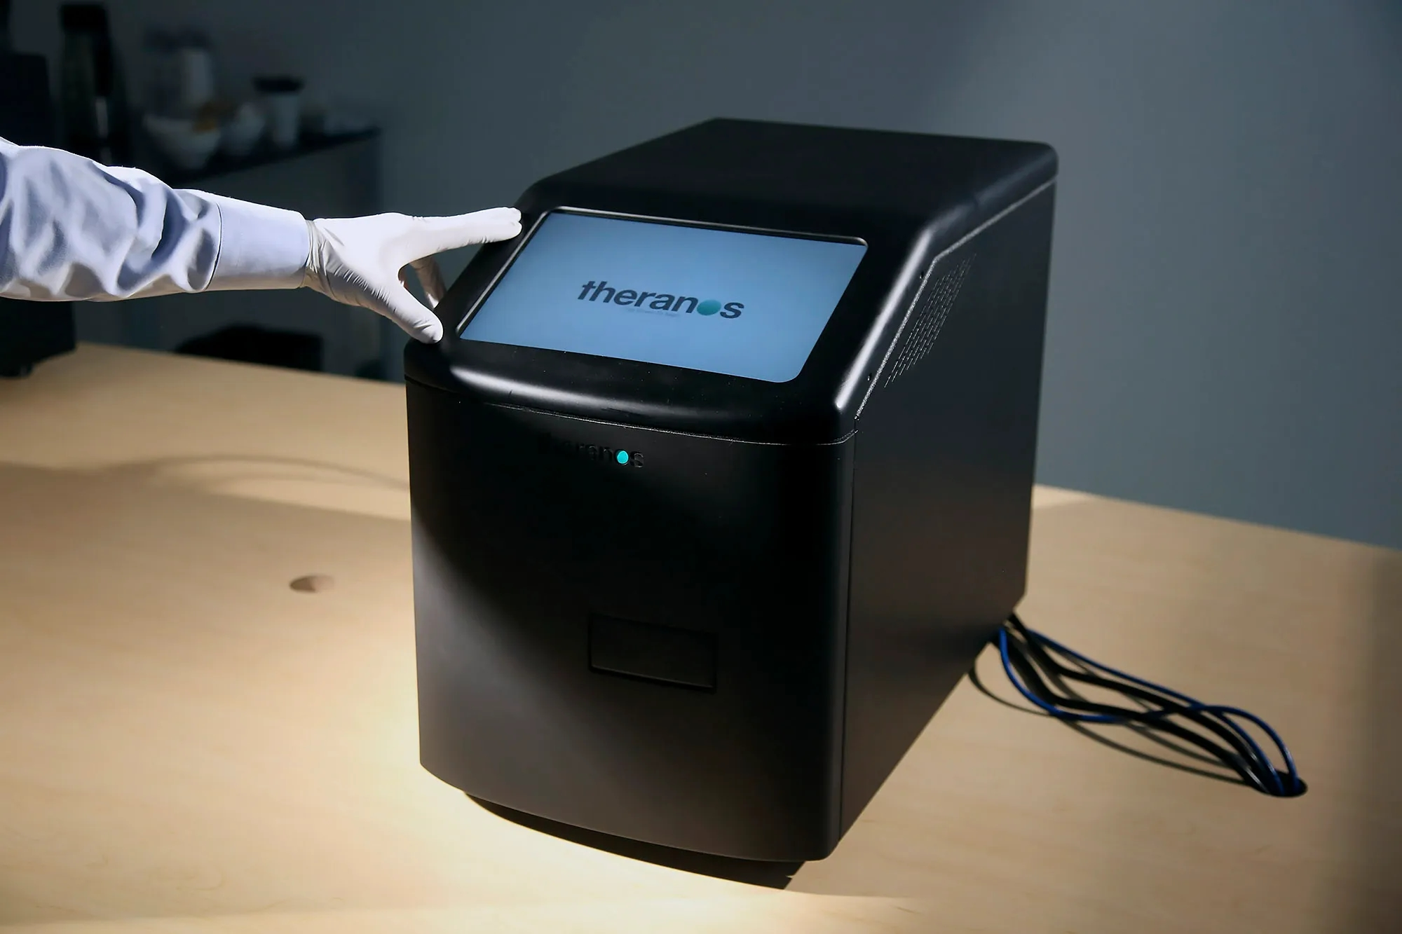Image: A blood-testing machine developed by Theranos in Palo Alto.JIM WILSON/THE NEW YORK TIMES/RE, source link: <https://www.wired.com/2016/10/theranos-blew-didnt-ruin-biotech-startups-everyone/>